Project Design Phase-II
Data Flow Diagram & User Stories

Date | 29-11-2025
Team ID
Project Name | Flight Booking
Maximum Marks | 4 Marks

Data Flow Diagrams:
A Data Flow Diagram (DFD) illustrates how data moves within the Flight Booking platform. It captures how users (customers, operators, and admins) interact with the system, how information flows between different processes, and where the data is stored.
Example DFD Level 0 (Industry Standard)

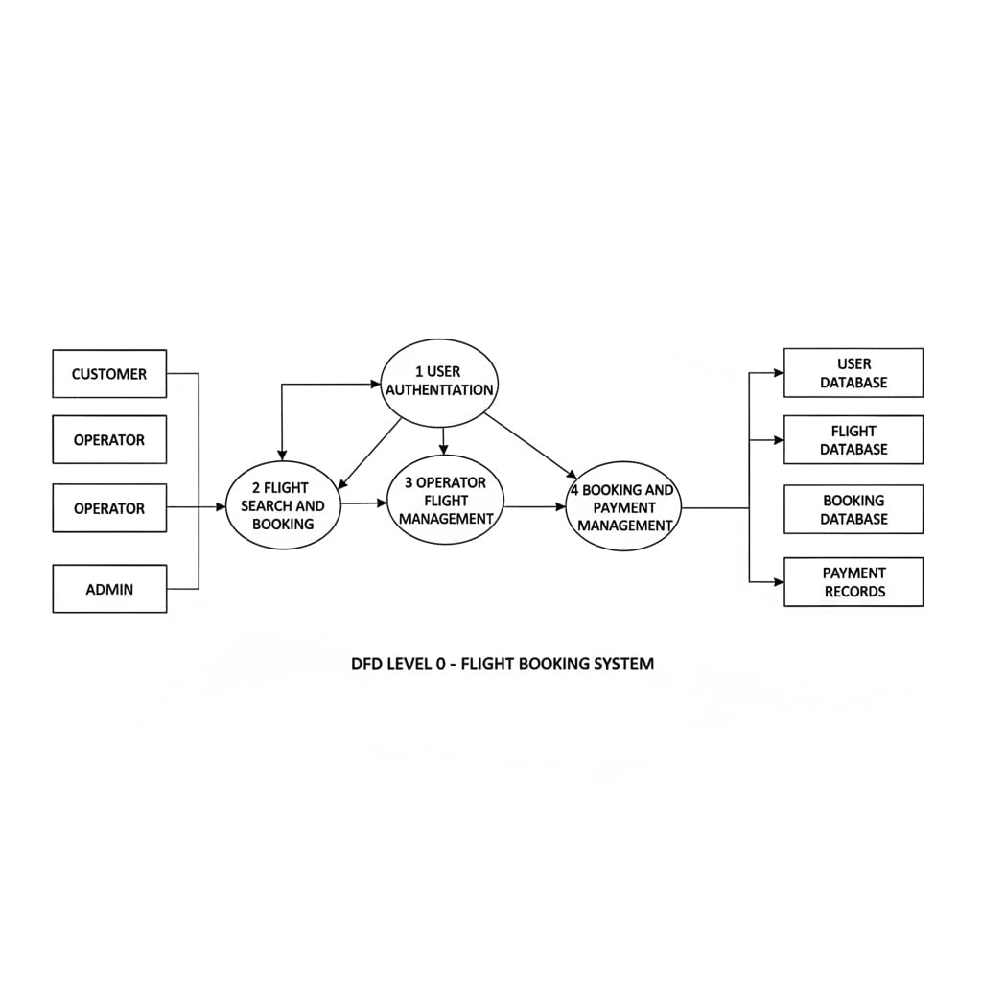

User Stories
User Story Table – Flight Booking

User Type | Functional requirement (Epic) | User story/Task | Acceptance criteria | Priority | Release
Customer | Flight Search & Browsing | As a customer, I can search flights by source, destination, date, and time. | Matching flights are listed with route, time, and pric | High | Sprint-1
Customer | Flight Booking | As a customer, I can book a seat on a selected flight. | Booking is created, seat is reserved, and confirmation is shown. | High | Sprint-1
Customer | Booking Management | As a customer, I can view and cancel my bookings. | Upcoming bookings are listed and cancellation updates booking status. | Medium | Sprint-2
Operator | Flight Management | As an operator, I can add, edit, and delete flights | Flights appear in the system and in customer search results | High | Sprint-1
Operator | Booking Overview | As an operator, I can view bookings for my flights. | Operator dashboard shows each flight with number of bookings. | Medium | Sprint-2
Admin | Operator Approval | As an admin, I can approve or reject operator registration requests | Approved operators can log in and manage flights; rejected cannot | High | Sprint-1
Admin | System Monitoring & Reports | As an admin, I can view reports of flights and bookings. | Reports show total flights, bookings, and basic revenue summary. | Medium | Sprint-2
User (Customer/Operator) | Authentication | As a user, I can sign up and log in securely | Valid users can log in; invalid credentials are rejected with error | Hign | Sprint-1
User (Customer) | Payment Processing | As a customer, I can pay securely for my flight booking (mock payment). | Payment status is stored and visible in booking details. | High | Sprint-2

